A SPARSE BAYESIAN LEARNING APPROACH TO MULTI-COMPONENT JITTER DECOMPOSITION
Qihang Sun¹, Zhensheng Zhang¹, Jing Peng¹, Zihao Li¹, Zhengshan Xu¹, Tonggang Zhao^{1*}
¹Beijing University of Posts and Telecommunications, Beijing 100876, China
*zhaotg@bupt.edu.cn

Keywords: Jitter decomposition; Periodic jitter; Sparse Bayesian learning; redundant dictionary

Abstract
Accurate decomposition of individual jitter components from a time interval error (TIE) sequence is essential for signal integrity assessment in high-speed digital communications. Existing frequency-domain methods estimate the periodic jitter (PJ) frequency by FFT peak-picking and fit the amplitudes by least squares. However, the non-uniform spacing of data transition edges in pseudo-random binary sequence (PRBS) signals violates the FFT's uniform-sampling assumption. The resulting frequency bias propagates to the amplitudes of all components.To address this limitation, a sparse Bayesian learning (SBL) approach to jitter decomposition is proposed. A redundant dictionary whose frequency resolution can be designed independently is constructed, and its active columns are identified by the automatic relevance determination (ARD) mechanism replacing FFT peak-picking. To accelerate the inference, the active frequencies are first localised on a coarse grid by the fast relevance vector machine (FastRVM); a fine ARD inference is then carried out within the resulting neighbourhoods.Experimental results show that, relative to the above baseline, the proposed method confines the PJ estimation error within 0.5 ps over the 100 kHz – 15 MHz band and suppresses error propagation to the ISI and RJ components, confirming the accuracy and robustness of the proposed approach.
- Introduction
As data rates in high-speed digital communications continue to rise, systems impose ever more stringent constraints on timing precision and signal integrity. Jitter, being the dominant factor that affects the bit error rate (BER), has become a key indicator in signal integrity assessment^{[1]}. Acquiring the time interval error (TIE) sequence with an oscilloscope and decomposing it precisely into its constituent components is the foundation for evaluating system performance and locating sources of disturbance^{[2]}. According to physical origin and statistical properties, total jitter (TJ) is conventionally split into random jitter (RJ) and deterministic jitter (DJ); the latter is further subdivided into inter-symbol interference (ISI), duty-cycle distortion (DCD) and periodic jitter (PJ) ^{[3]}.

Existing jitter decomposition methods can be broadly grouped into statistical-domain, time-domain and frequency-domain approaches. Statistical-domain methods, exemplified by tail fitting ^{[4]} and the dual-Dirac model ^{[5, 6]}, achieve a fast separation of RJ and DJ but provide no explicit model for the pattern dependence of ISI. Time-domain methods such as time lag correlation (TLC) ^{[7]} employ correlation functions to separate correlated and uncorrelated jitter components but cannot directly extract the frequency information of PJ. Frequency-domain methods such as the FFT-based spectral peak-picking^{[8]} reveal the frequency structure of PJ intuitively but likewise lack an explicit model for the pattern dependence of ISI. Recently, deep-learning-based methods^{[9]} have also made some progress, although they typically rely on large amounts of labelled data and offer limited interpretability.

Duan^{[10]} proposed a least-squares decomposition based on a linear superposition model of the TIE, in which the PJ frequency is located by FFT peak-picking and the amplitudes are then fitted by least squares (referred to here as LS-FFT). The method incorporates the four components — PJ, ISI, DCD and RJ — into a unified linear model, and the amplitude of each component can be estimated jointly from a small number of TIE samples. The accuracy of this method, however, hinges on an accurate FFT frequency estimate. The TIE is defined only at data transition edges; consecutive identical bits in real data patterns produce no transition, so adjacent TIE samples are not equally spaced on the time axis and the uniform-sampling assumption of the FFT is violated. The FFT peak therefore deviates from the true PJ frequency (Fig. 1). Furthermore, when the PJ frequency falls between two DFT bins, the picket-fence effect aggravates this bias. Fitting the PJ component with a frequency that has been shifted, the basis functions no longer align with the true signal; the amplitude estimate becomes inaccurate and errors propagate to the ISI and RJ components.
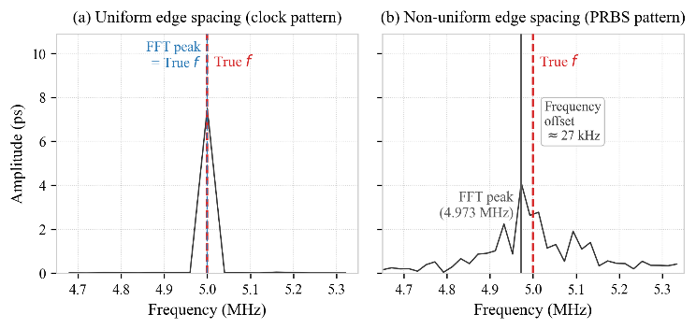
Fig. 1 Non-uniform edge distribution of a PRBS signal.

To address this issue, a multi-component jitter decomposition method based on sparse Bayesian learning (SBL) is proposed. Extending the linear superposition model of ^{[10]}, a redundant dictionary containing a large set of candidate frequencies is constructed using the actual transition instants in place of a single frequency column, so that the spacing and number of candidate frequencies are no longer constrained by the number of samples. The automatic relevance determination (ARD) mechanism of SBL is then used to select the true PJ frequency directly from the redundant dictionary. FFT peak-picking is is therefore eliminated, avoiding the frequency-estimation bias introduced by non-uniform sampling and the picket-fence effect.

- Signal Model and Dictionary Construction

2.1 Linear TIE Model
The TIE at the kth transition edge can be decomposed, according to its physical origin, into a linear superposition of deterministic components and random noise:

$$\begin{aligned}y\left(k\right)=y_{PJ}\left(k\right)+y_{ISI}\left(k\right)+y_{DCD}\left(k\right)+v\left(k\right)\#\left(1\right)\end{aligned}$$

where $v\left(k\right)$ comprises random jitter and observation noise. Stacking the TIE samples over $N$ transition edges in matrix form^{[10]}:

$$\begin{aligned}y=\left[A\left(f_{0}\right) ∣ B ∣ C\right]x+v\#\left(2\right)\end{aligned}$$

The PJ sub-matrix $A\left(f_{0}\right)∈R^{N×2}$ has columns $d_{n}cos\left(2πf_{0}n/f_{s}\right)$ and $d_{n}sin\left(2πf_{0}n/f_{s}\right)$, where $d_{n}$ is the transition indicator (1 at a transition, 0 otherwise); the DCD sub-matrix $B∈R^{N×1}$ is set to $+1$ on rising edges and $-1$ on falling edges; the ISI sub-matrix $C∈R^{N×2^{L}}$ buckets the rows by the history pattern within memory depth $L$, placing a $1$ in the column corresponding to the current pattern of each row.

The accuracy of the solution to (2) hinges on whether $A\left(f_{0}\right)$ reflects the true phase structure of the PJ component on the TIE sequence. The phase term $2πf_{0}n/f_{s}$ in the nth row of $A\left(f_{0}\right)$ approximates the nth transition as a uniformly sampled point at $n/f_{s}$. Under PRBS patterns, however, consecutive identical bits produce no transition, so adjacent transitions are not equally spaced in time; the phase bias introduced by this approximation causes the FFT-based estimate of $f_{0}$ to deviate systematically from its true value, and the bias is propagated through the least-squares fit to the PJ and the other component amplitudes.

2.2 Redundant Frequency Dictionary
Rather than relying on FFT peak-picking, this paper places $K$ candidate frequencies in the target band, constructs the dictionary column for each candidate using the actual transition arrival times $t_{n}$, and identifies the active frequencies by SBL. Here $t_{n}$ denotes the ideal arrival time of the nth transition edge: in a PRBS test the transmitted pattern is known, so the transition positions can be determined directly from the pattern, $t_{n}=\text{edge_index}\left(n\right)/f_{s}$, and this information is available when the TIE sequence is extracted.
For each candidate frequency $f_{i}$, a pair of cosine and sine basis columns is constructed:

$$\begin{aligned}\begin{aligned}h_{c,i}&=[d_{1}cos(2πf_{i}t_{1}),…,d_{N}cos(2πf_{i}t_{N})]^{T} \\ h_{s,i}&=[d_{1}sin(2πf_{i}t_{1}),…,d_{N}sin(2πf_{i}t_{N})]^{T}\end{aligned}\#\left(3\right)\end{aligned}$$

A PJ component with arbitrary initial phase can be expressed linearly as $a_{i}h_{c,i}+b_{i}h_{s,i}$, converting non-linear phase estimation into linear coefficient estimation. Concatenating the basis-column pairs of the $K$ candidate frequencies horizontally yields the PJ sub-dictionary

$$\begin{aligned}H_{PJ}=\left[h_{c,1},h_{s,1},…,h_{c,K},h_{s,K}\right]∈R^{N×2K}\#\left(4\right)\end{aligned}$$

The spacing and number of the candidate frequencies $f_{1},…,f_{K}$ are not constrained by the DFT grid $Δf=f_{s}/N$ and may be chosen flexibly according to the target band. Concatenating $H_{PJ}$ with $B$ and $C$ yields the global redundant dictionary:

$$\begin{aligned}H=\left[H_{PJ} ∣ B ∣ C\right]∈R^{N×M}, M=2K+1+2^{L}\#\left(5\right)\end{aligned}$$

After solving for the coefficient vector $\hat{x}$, the physical quantity of each component is extracted as follows. The coefficient pair $\left({\hat{a}}_{i},{\hat{b}}_{i}\right)$ at an active frequency $f_{i}$ gives the peak-to-peak PJ amplitude

$$\begin{aligned}{\text{Pk-Pk}}_{PJ}=2\sqrt{{\hat{a}}_{i}^{2}+{\hat{b}}_{i}^{2}}\#\left(6\right)\end{aligned}$$

The DCD and ISI peak-to-peak values are ${\text{Pk-Pk}}_{DCD}=2\left|{\hat{x}}_{DCD}\right|$ and ${\text{Pk-Pk}}_{ISI}=max\left({\hat{x}}_{ISI}\right)-min\left({\hat{x}}_{ISI}\right)$, respectively; the RMS RJ is estimated from the fitting residual,

$$\begin{aligned}{\hat{σ}}_{RJ}=\sqrt{\frac{∥y-H\hat{x}∥_{2}^{2}}{N-P}}\#\left(7\right)\end{aligned}$$

where $P$ is the number of active columns in $H$.

Adjacent candidate-frequency columns of $H$ are highly correlated, $H^{T}H$ is severely ill-conditioned, and a direct least-squares solution is numerically unstable. In a real system the number of PJ disturbance sources present simultaneously is small, so only a few entries of the coefficient vector are non-zero, and the problem reduces to identifying the columns associated with these non-zero coefficients and estimating their values. Sparse Bayesian learning (SBL) provides a probabilistic inference framework for sparse-recovery problems of this kind^{[11]}.

- SBL-Based Jitter Decomposition Algorithm
The frequency resolution of the redundant dictionary is not bounded by the number of samples, but a finer resolution requires a larger number of candidate columns. If a fine dictionary with thousands of columns is constructed directly, ARD must update all columns simultaneously, with a computational cost that grows quadratically with the number of columns and a single-pass inference time that exceeds engineering tolerance. FastRVM uses a sequential update that processes one column per step and remains efficient on large coarse-grid dictionaries, but its coarse spacing limits the achievable frequency resolution. The inference is therefore carried out in two stages: FastRVM first localises the active PJ frequencies on a coarse grid, and a fine dictionary is then constructed within the localised intervals so that ARD yields accurate frequency and amplitude estimates. Both stages identify the active columns by maximising the marginal likelihood. The complete algorithmic flow is shown in Fig. 2.
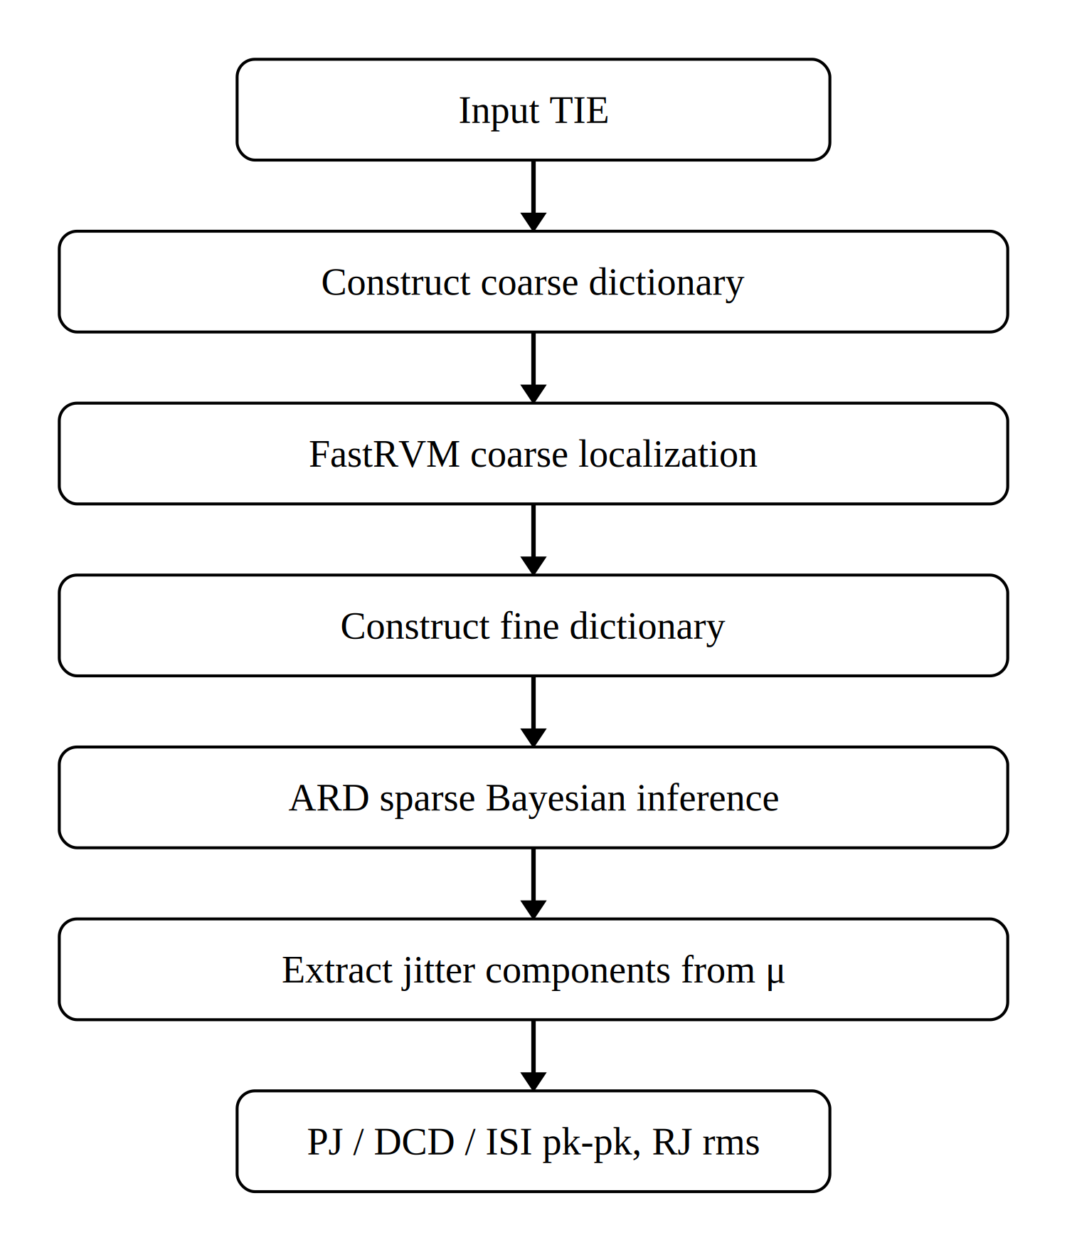
Fig. 2 Flowchart of the SBL-based jitter decomposition algorithm.

3.1 FastRVM Coarse Localisation
The aim of the coarse-localisation stage is to determine the approximate intervals of the PJ frequencies within the 100 kHz – 15 MHz band.
SBL assigns an independent zero-mean Gaussian prior to each entry of the coefficient vector $w$^{[11]}:

$$\begin{aligned}w_{i}∼N\left(0,α_{i}^{-1}\right)\#\left(8\right)\end{aligned}$$

where $α_{i}$ is the precision hyperparameter; $α_{i}→∞$ effectively prunes the corresponding column from the model. The hyperparameters $α_{i}$ are estimated from the data by maximisation of the marginal likelihood, and on convergence only a few columns retain a finite $α_{i}$, achieving sparse recovery.

100 candidate frequencies are uniformly placed across 100 kHz – 15 MHz, giving a 200-column PJ sub-dictionary by (3)–(4); concatenation with $B$ and $C$ yields a coarse global dictionary of 233 columns. Sequential sparse inference^{[12]} is then applied to this dictionary by FastRVM. Let the observation model be $y=Hw+ε$ with $ε∼N\left(0,σ^{2}I\right)$.

Rather than iterating on all columns simultaneously, FastRVM maintains an active set $A$, initially empty, and at each step decides whether to add or remove a single column. When the ith column is examined, its quality factor $Q_{i}$ and sparsity factor $S_{i}$ relative to the current residual are computed:

$$\begin{aligned}Q_{i}=h_{i}^{T}Φ^{-1}y, S_{i}=h_{i}^{T}Φ^{-1}h_{i}\#\left(9\right)\end{aligned}$$

where $h_{i}$ is the ith dictionary column and $Φ=σ^{2}I+H_{A}Λ_{A}^{-1}H_{A}^{T}$ is the marginal covariance for the current active set $A$. $Q_{i}$ measures the contribution of column $i$ to fitting the residual and $S_{i}$ reflects its energy. Together, they form the sparsity–quality criterion^{[12]}:

$$\begin{aligned}θ_{i}=Q_{i}^{2}-S_{i}\#\left(10\right)\end{aligned}$$

If $θ_{i}>0$, the fit improvement obtained by including the column outweighs the complexity penalty of admitting it; the column is added to the active set, and $α_{i}$ is updated to its closed-form maximiser of the marginal likelihood:

$$\begin{aligned}α_{i}^{new}=\frac{S_{i}^{2}}{θ_{i}}\#\left(11\right)\end{aligned}$$

If $θ_{i}≤0$, $α_{i}$ is set to infinity and the column is removed from the model. The above procedure is applied sequentially to each column and iterated until the active set no longer changes. After convergence, for every candidate frequency $f_{k}$ the relevances of its sine and cosine columns are summed, $1/α_{2k-1}+1/α_{2k}$, and the candidates are ranked in decreasing order of this sum; the three highest are taken as the candidate centre frequencies ${\hat{f}}_{1},{\hat{f}}_{2},{\hat{f}}_{3}$ for the subsequent fine inference. The coarse-localisation result is shown in Fig. 3(a).

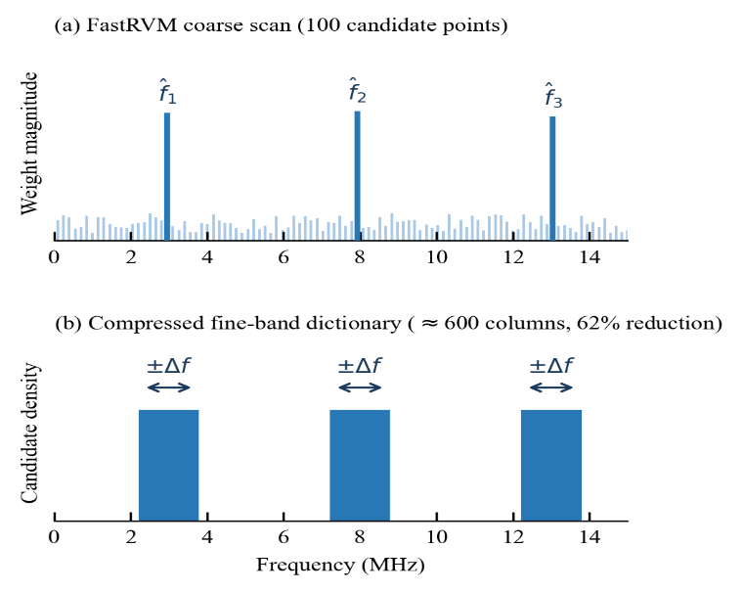
Fig. 3 FastRVM coarse localisation and ARD fine-dictionary construction.

3.2 ARD-Based Fine Frequency Identification
The frequency resolution of FastRVM on the coarse grid is approximately 150 kHz, so ${\hat{f}}_{1},{\hat{f}}_{2},{\hat{f}}_{3}$ provide only the approximate location of the true frequencies; a fine dictionary is required in the surrounding neighbourhoods to deliver an accurate frequency and amplitude estimate. A fine window of $±200$ kHz is centred at each ${\hat{f}}_{i}$, covering the coarse-localisation error of FastRVM (about $±75$ kHz) and ensuring that the true PJ frequency lies inside the window. 100 candidate frequencies are uniformly placed in each window with a spacing of approximately 4 kHz, and the three windows are merged to give 300 fine candidate frequencies. The fine global dictionary $H∈R^{N×M}$ is then assembled via (3)–(5), giving $M=600+1+32=633$ (Fig. 3(b)).

Adjacent fine-candidate columns are highly correlated and a direct least-squares solution is numerically unstable. The same ARD prior as in (8) is imposed on $H$. By the conjugacy of the Gaussian prior and the Gaussian observation model, the posterior distribution $p\left(w ∣ y\right)$ is Gaussian, with mean and covariance

$$\begin{aligned}μ=σ^{-2}ΣH^{T}y, Σ={\left(σ^{-2}H^{T}H+Λ\right)}^{-1}\#\left(12\right)\end{aligned}$$

where $Λ=diag\left(α_{1},…,α_{M}\right)$. The posterior mean $μ$ serves as the coefficient estimate.
The hyperparameters $α_{i}$ and the noise variance $σ^{2}$ are not specified manually; they are estimated jointly from the data by maximising the marginal likelihood $p\left(y ∣ α_{i}\right\},σ^{2}$, with the update rules

αinew=1-αiΣiiμi2, (σ2)new=∥y-Hμ∥2N-i​(1-αiΣii) 13

where $Σ_{ii}$ is the ith diagonal entry of the posterior covariance matrix. The updates of $α_{i}$ and $σ^{2}$ are alternated until convergence.

After inference, the posterior mean $μ$ is taken directly as the coefficient estimate of each component: the coefficient pairs $\left({\hat{a}}_{i},{\hat{b}}_{i}\right)$ at the active frequencies provide the peak-to-peak PJ amplitude via (6); the DCD and ISI coefficients give the corresponding component amplitudes; and the RMS RJ is estimated from the residual via (7).
- Experimental Result
To verify the effectiveness of the proposed method, simulations are conducted to evaluate the wide-band PJ estimation accuracy and the multi-component joint decomposition accuracy, comparing LS-FFT^{[10]} against the proposed SBL method. The simulated data are TIE sequences generated under PRBS-7 patterns at a 2 Gbps data rate, with 50 000 samples collected, channel memory depth $L=5$, and DCD and ISI ground truths set to 1.0 ps and 0.16 ps, respectively. Since the FFT peak shift varies with the PJ frequency, the experiments scan the PJ frequency over 100 kHz – 15 MHz to compare the decomposition performance of the two methods. Two parameter sets are used: Sample 1 with PJ = 10.0 ps and RJ = 5.0 ps; Sample 2 with PJ = 6.0 ps and RJ = 5.0 ps.
Six frequency points (0.1, 0.5, 1, 5, 10 and 15 MHz) are selected within 100 kHz – 15 MHz, and the peak-to-peak PJ estimation errors of the two parameter sets are shown in Fig. 4.
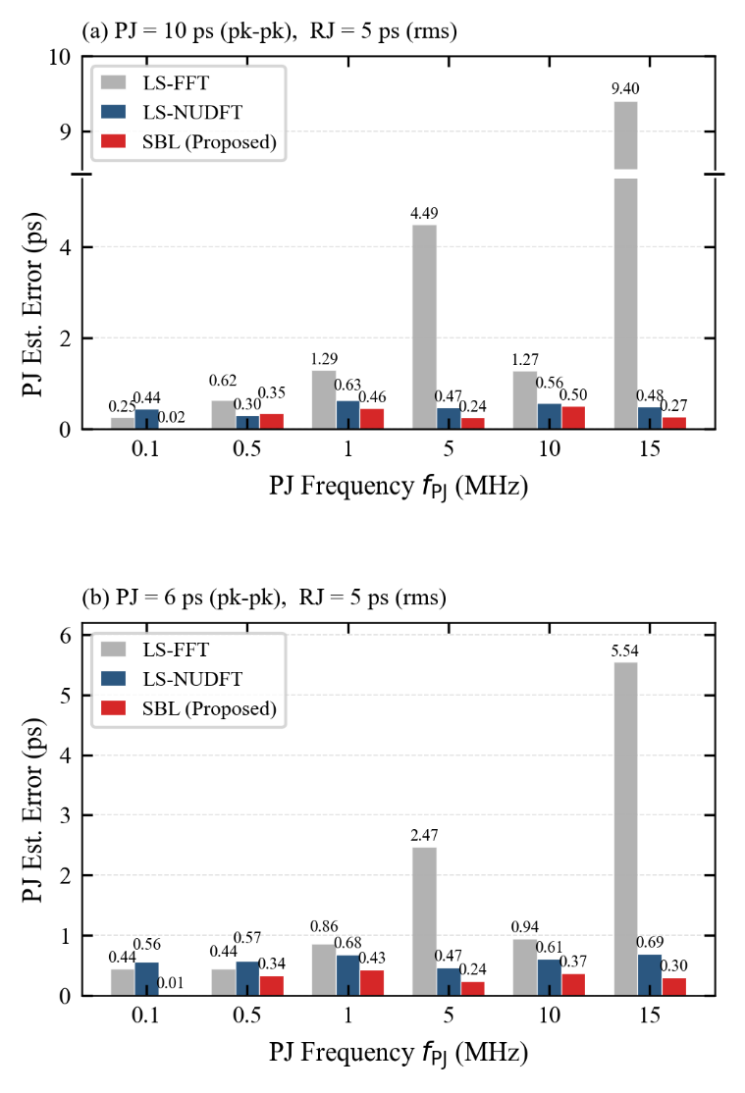
Fig. 4 Wide-band PJ estimation errors for the two samples.
As shown in Fig. 4, in both samples and at all six frequency points the SBL PJ error remains below 0.5 ps with no clear dependence on frequency, whereas the LS-FFT PJ error grows with frequency and reaches 9.40 ps (Sample 1) and 5.54 ps (Sample 2) at 15 MHz, exceeding the SBL error by one to two orders of magnitude. This is because the LS-FFT PJ error is dominated by the FFT frequency-estimation bias: the higher the frequency, the larger the relative shift between adjacent DFT bins, and the larger the resulting estimation error. SBL identifies the active frequencies directly from the redundant dictionary and does not rely on the uniform-sampling assumption, so its error does not vary with frequency.
Three frequency points (0.1, 1.0 and 10.0 MHz) are then chosen to compare the simultaneous decomposition accuracy of the four components — PJ, DCD, ISI and RJ — and the errors are reported in Table 1.

Table 1 Multi-component decomposition errors (ps). Ground truth -- Sample 1: PJ = 10.00, DCD = 1.00, ISI = 0.16, RJ = 5.00; Sample 2: PJ = 6.00, DCD = 1.00, ISI = 0.16, RJ = 5.00.
Sample | f_{PJ}  (MHz) | LS-FFT Error (ps) |  |  |  |  | LS-NUDFT Error (ps) |  |  |  |  | SBL Error (ps)
 |  | PJ | DCD | ISI | RJ |  | PJ | DCD | ISI | RJ |  | PJ | DCD | ISI | RJ
1 | 0.1 | 0.25 | 0.04 | 0.41 | 0.01 |  | 0.44 | 0.04 | 0.40 | 0.02 |  | 0.02 | 0.03 | 0.30 | 0.01
 | 1.0 | 1.29 | 0.04 | 0.48 | 0.06 |  | 0.63 | 0.04 | 0.42 | 0.02 |  | 0.46 | 0.03 | 0.30 | 0.01
 | 10.0 | 1.28 | 0.04 | 0.44 | 0.55 |  | 0.56 | 0.04 | 0.42 | 0.02 |  | 0.50 | 0.03 | 0.30 | 0.02
2 | 0.1 | 0.44 | 0.04 | 0.42 | 0.01 |  | 0.56 | 0.04 | 0.41 | 0.00 |  | 0.01 | 0.03 | 0.30 | 0.01
 | 1.0 | 0.86 | 0.04 | 0.44 | 0.01 |  | 0.68 | 0.04 | 0.42 | 0.02 |  | 0.43 | 0.03 | 0.30 | 0.01
 | 10.0 | 0.94 | 0.04 | 0.42 | 0.20 |  | 0.61 | 0.04 | 0.42 | 0.02 |  | 0.37 | 0.03 | 0.30 | 0.02

As shown in Table 1, in both samples and at all three frequency points the SBL PJ error stays within 0.50 ps, while the DCD and RJ errors are bounded by 0.03 ps and 0.02 ps respectively. The LS-FFT PJ error reaches 1.28 ps (Sample 1) and 0.94 ps (Sample 2) at 10.0 MHz, and at this frequency the RJ error of Sample 1 rises to 0.55 ps, indicating that the LS-FFT frequency shift misaligns the PJ basis functions with the true signal so that the unfit PJ energy is absorbed into the residual and biases the RJ estimate. The SBL RJ estimate stays close to its ground truth at all settings, confirming that accurate frequency identification eliminates this cross-component error propagation. Both methods over-estimate the ISI by approximately 0.30 ps regardless of the PJ frequency, which is caused by finite-sample statistical accumulation of RJ noise when the conditional means of $C$ are taken over its $2^{L}=32$ pattern bins; this bias is intrinsic to the ISI sub-model.
- Conclusion
This paper presented a sparse Bayesian learning approach to multi-component jitter decomposition. The method retains the linear superposition model of LS-FFT but replaces the single-frequency column with a redundant frequency dictionary, and uses the ARD mechanism to identify the active PJ frequencies without any frequency prior. The PJ estimation accuracy remains stable across the wide band, and error propagation to the RJ component is suppressed. Future work will validate the method on measured oscilloscope data.
- Acknowledgements
This work is supported by the National Key Research and Development Program of China (2022YFF0707104).
7 References
[1] Balestrieri, E., Picariello, F., Rapuano, S., et al.: ‘Review on jitter terminology and definitions’, Measurement, 2019, 145, pp. 264–273
[2] Chen, J., Ye, P., Zhao, Y., et al.: ‘Methodology for jitter analysis in digital storage oscilloscope’, Proc. IEEE 16th Int. Conf. Electronic Measurement & Instruments (ICEMI), Harbin, China, August 2023, pp. 1–6
[3] Tripathi, J.N., Sharma, V.K., Shrimali, H.: ‘A review on power supply induced jitter’, IEEE Trans. Compon. Packag. Manuf. Technol., 2019, 9, (3), pp. 511–524
[4] Deng, Y., Shang, Z., Tang, Z., et al.: ‘Jitter analysis and decomposition based on tail-fit algorithm’, Proc. 2024 4th Int. Conf. Communication Technology and Information Technology (ICCTIT), Guangzhou, China, December 2024, pp. 611–615
[5] Fang, S., Pan, W., Pan, D., et al.: ‘Jitter analysis based on kernel density estimation and dual-Dirac’, Proc. IEEE Int. Conf. Signal, Information and Data Processing (ICSIDP), Zhuhai, China, November 2024, pp. 1–6
[6] Peng, J., Qi, Z., Li, Z., et al.: ‘Jitter decomposition based on dual-Dirac model: a two-stage limited-sampling algorithm’, Proc. IEEE 17th Int. Conf. Electronic Measurement & Instruments (ICEMI), Beijing, China, August 2025, pp. 169–174
[7] Dou, Q., Abraham, J.A.: ‘Jitter decomposition by time lag correlation’, Proc. 7th Int. Symp. Quality Electronic Design (ISQED), San Jose, CA, USA, March 2006, pp. 525–530
[8] Yamaguchi, T.J., Ishida, M., Hou, H.X., et al.: ‘An FFT-based jitter separation method for high-frequency jitter testing with a 10× reduction in test time’, Proc. IEEE Int. Test Conf. (ITC), Santa Clara, CA, USA, October 2007, pp. 1–8
[9] Ren, N., Fu, Z., Zhou, D., et al.: ‘Jitter decomposition by convolutional neural networks’, IEEE Trans. Electromagn. Compat., 2021, 63, (4), pp. 1550–1561
[10] Duan, Y., Chen, D.: ‘Fast and accurate decomposition of deterministic jitter components in high-speed links’, IEEE Trans. Electromagn. Compat., 2019, 61, (1), pp. 217–225
[11] Tipping, M.E.: ‘Sparse Bayesian learning and the relevance vector machine’, J. Mach. Learn. Res., 2001, 1, pp. 211–244
[12] Faul, A.C., Tipping, M.E.: ‘Analysis of sparse Bayesian learning’, in Dietterich, T.G., Becker, S., Ghahramani, Z. (Eds.): ‘Advances in Neural Information Processing Systems 14’ (MIT Press, Cambridge, MA, 2002), pp. 383–389

